CSC630-Computer Graphics Design.
Project #3
Dr. Kroll

The Amazing Maze

Delfin Rojas
George Sellas
Anthony dela Calzada
Carlos Ferreira

1. Introduction

This project will focus mainly in developing a 3D MAZE game. This will be an impressive maze where the player will have a chance to walk around a series of different paths through three dimensional walls. The goal is to reach the end of the path.
The amazing part of this game is expected to be the 3D feel that is given while the player rolls the ball down the path. This scenario attempts to engage the player because it will make him feel good; it will make him feel like he’s playing a hot high tech maze game-an amazing one which is made out of 3D walls and floors-maybe ceilings too if time permits.
We had discussed some of the challenges that our group could face while developing this game. Probably the main challenge seems to be the application of special textures to the walls and floors. This will need to happen simultaneously while the ball moves down the aisles. Another challenge seems to be the different choices of difficulty levels used to traverse the maze.
We feel very confident that we will be able to figure out how to overcome these difficulties. We will develop the final product on time and in good working order.
In the end, we hope to have an amazing and engaging 3D maze game that will make the players screaming for more.
The following image serves as an inspiration for a possible look of our amazing game, although we are not sure how similar we can get.

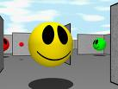

2. Design and Architecture

2.1 Scenes

The project team agreed to organize the code in sections that are called “scenes”. The different scenes can be thought of a collection of actions and content which can be grouped together to offer some specific functionality.
Below is a diagram that depicts the navigation beginning at the “Startup Scene” and following the chosen paths to the “Credits”, “GamePlay”, “Demo” and “Instructions” scenes.
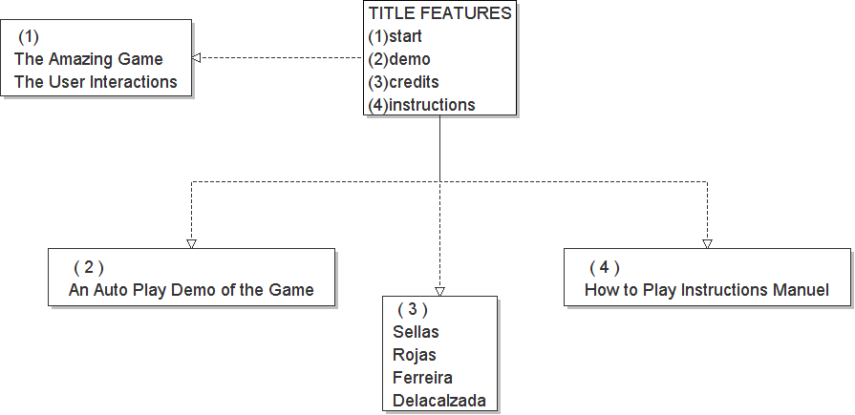

2.2 Background Music

An array of varied song selections will be played while the user goes through the intricate holes and walls. The scenario is made out of selected textures and coordinated colors so that a greater realism is achieved when the images of the maze appears on the computer screen.

2.3 Demo Mode

The Demo scene (demo mode) will auto play the game quickly so that the user can have some idea of what to expect. If the user needs some help on what to do then he/she might decide to take a look at the instructions on how to do it.
And lastly the names of the team members appear if the Credits scene is pulled up.

2.4 Third Party Libraries

The following third party libraries were used in the project:
- OpenGL
- CPW 1.0b for OpenGL window helper functions
- Boost 1.34.1 for smart pointers and generic function binding.
- DevIL 1.6.8 to load textures from JPEG, BMP, PNG and other image files.
- FreeType 2.3.5 for drawing TrueType fonts.
- Audiere 1.9.4 for playing audio files in MP3 and other formats.

3. Gameplay

3.1 Main Screen

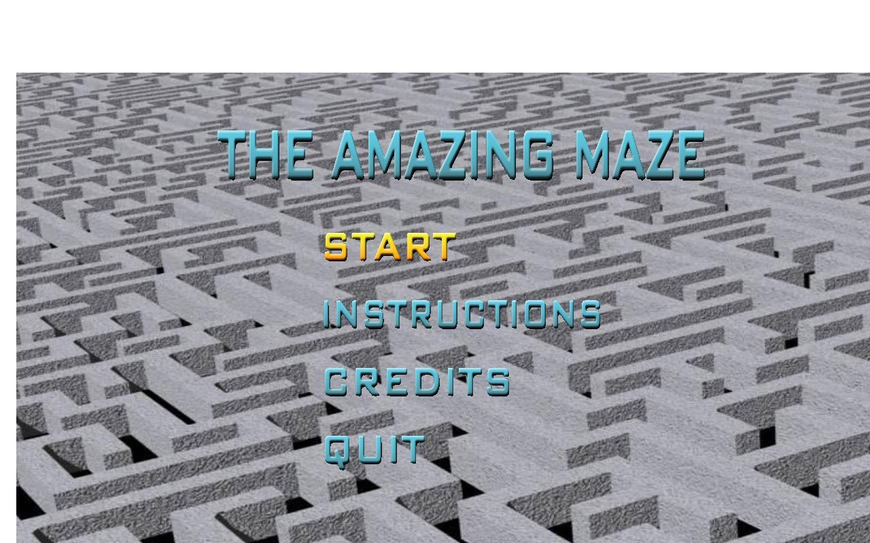
The game starts out at the main screen (shown below) which is straightforward and simple.

Use the up and down arrow keys to highlight a choice and press 'Enter' to select it. The available selections include:

- Start: Starts the game
- Demo: Starts the game in auto mode (moves to the end automatically).
- Instructions: Show the game instructions.
- Credits: Show the game credits
- Quit: Exit the game

3.2 Credits Screen

You may access the credits screen from the main screen. The credits screen (shown below) shows the credits for the game.
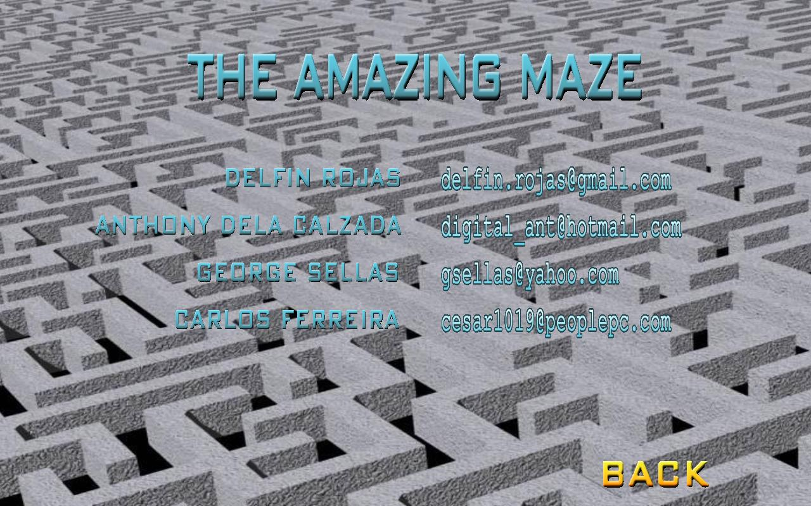
To return to the main screen either press “Q” or select “back” by pressing Enter.

3.3 Instructions Screen

You may access the instructions screen from the main screen by selecting “Instructions” or during the game by pressing the ‘I’ key.
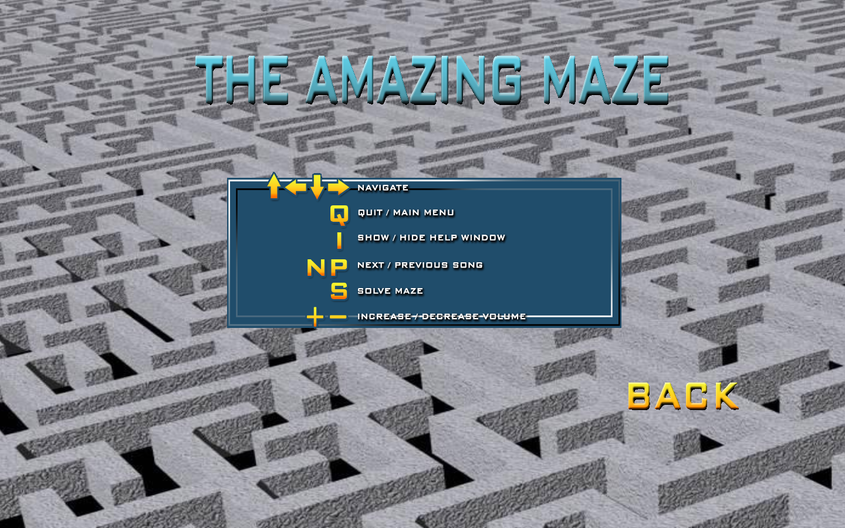
To return to the previous screen (main screen or game play screen) select “Back” by pressing Enter.

3.4 Playing the Game

To play the game, select the “Start” option on the main screen. Our Amazing Maze game will generate a random maze for you and move it into view (in an animation).
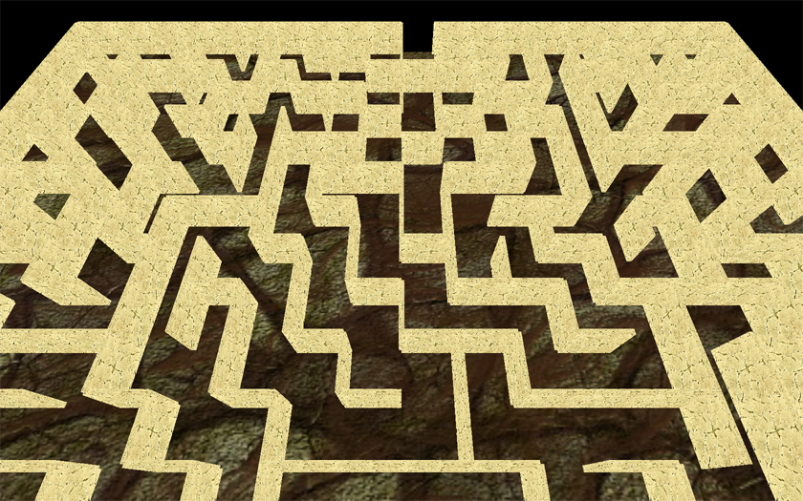
After the animation has finished the player “ball” will show at the entrance of the maze.
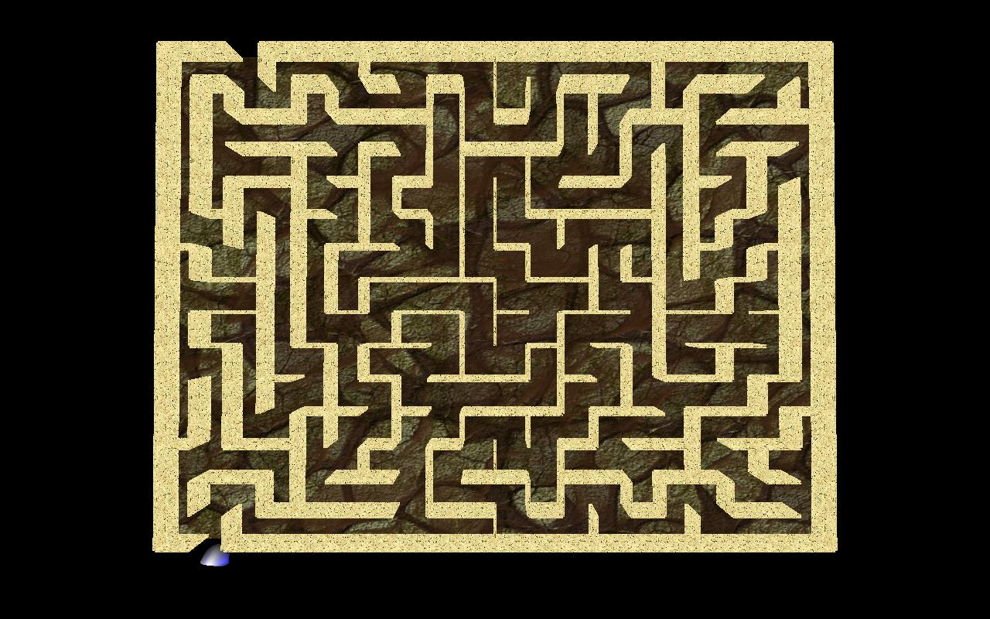
Move around the maze to the exit with the arrow keys. At any point you may press the ‘S’ key to have the player ball find the path to the exit by itself. When you win the game a cheering sound will be played and a little bit later you will be taken back to the main screen.
While playing the game you can press ‘I’ to get instructions and ‘Q’ to return to the main screen.

3.5 Demo mode

To have the Amazing Maze move by itself (demo mode) select Start on the main screen and start the game as usual. When the maze intro animation has stopped and the walker “ball” is visible press ‘S’ to enter auto/demo mode.

4. Additional Information

4.1 Project Hosting

Our project is hosted as an open source project on Google Code. The project is licensed under the "New BSD License".
The project homepage is located at: http://code.google.com/p/amazing-maze/
To checkout a read-only copy of the project source anonymously over HTTP use the following SVN details:
svn checkout http://amazing-maze.googlecode.com/svn/trunk/ amazing-maze-read-only

4.2 Teamwork

The Amazing Maze was a created thanks to the collaborative effort of all team members. Here is a high level breakdown of the tasks:
- Delfin Rojas: Project organization, EGL framework, and automatic maze solver.
- George Sellas: Music selection and playback, game start animation, positions, camera angles and
- Anthony dela Calzada: Selecting and/or creating textures for the maze background, maze walls, and for every piece of text in the game.
- Carlos Ferreira: Comprehensive documentation.

4.3 Software Requirements

In order to run the game you must have the Visual C++ 2008 runtime installed on your machine. You may download the runtime directly from Microsoft at http://www.microsoft.com/downloads/details.aspx?familyid=9B2DA534-3E03-4391-8A4D-074B9F2BC1BF&displaylang=en
In order to open the project/solution you need Visual Studio 2008.

5. References

The textures used on the maze floor and walls can be found on the site- http://www.spiralgraphics.biz/index.htm.
The background for the main screen, the credits screen and the instructions screen was taken from http://www.wingimp.org/tutorial/3d_maze/3dmaze.jpg
Last but not least, the maze generation code was inspired by the 3D maze made by Jeff Paquette which can be downloaded from http://www.atnetsend.net/computing/3dmaze/

